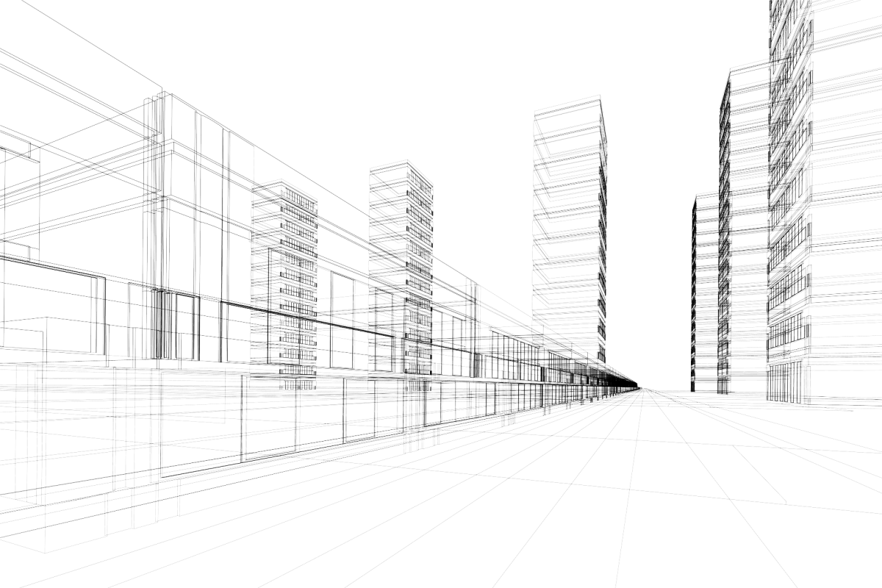


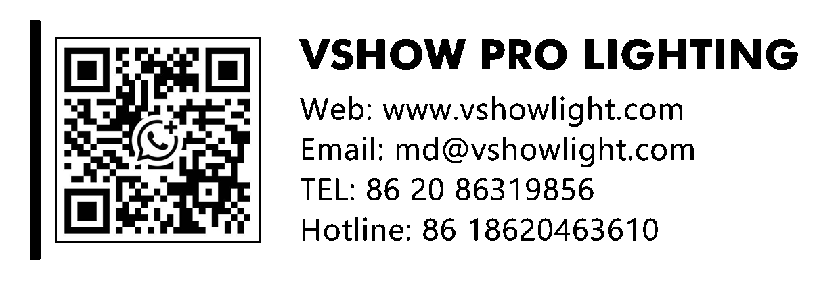


MODEL: S600

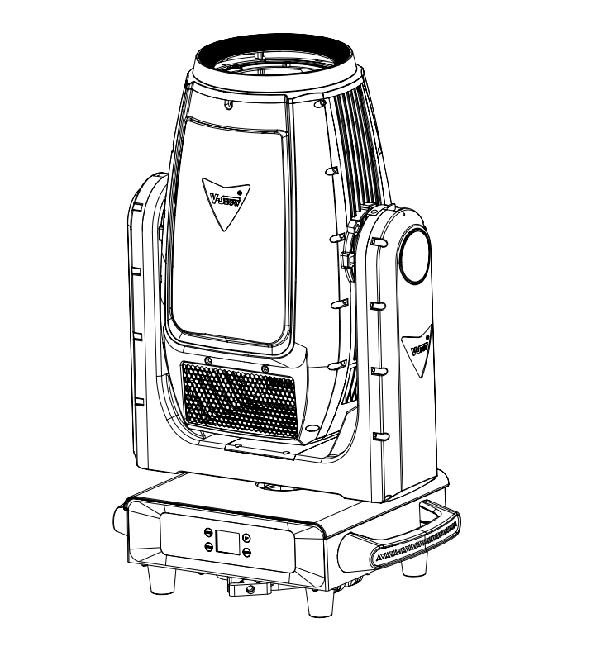

1. Safety Instructions
Please read the instruction carefully which includes important information
about the installation, usage and maintenance.
l Please keep this User Guide for future consultation. If you sell the unit to another user, be sure that they also receive this instruction manual.
l Unpack and check carefully to ensure that there is no transportation damage before using the unit.
l This product is suitable for wet locations. Do not immerse in water.
l DO install and operate by qualified operator.
l DO NOT allow children to operate the fixture.
l Use safety chain when fixing the unit. Handle the unit by carrying its base instead of head only.
l The unit must be installed in a location with adequate ventilation, at least 50cm from adjacent surfaces.
l Be sure that no ventilation slots is blocked, otherwise the unit will be overheated.
l Before operation, ensure that you are connecting this product to the proper voltage in accordance with the specifications in this manual or on the
product’s specification label.
l It’s important to ground the yellow/green conductor to earth in order to avoid electric shock.
l Minimum ambient temperature TA: -40℃ . Maximum ambient temperature TA: 160℃ . Do not operate this product at a lower or higher temperature.
l DO NOT connect the device to any dimmer pack
l Keep flammable materials away from the fixture while operating to avoid fire hazard.
l Make sure the power cord is not crimped or damaged; replace it immediately if damaged
l Unit’s surface temperature may reach up to 65℃ . DO NOT touch the housing bare-handed during its operation
l Avoid any flammable liquids, water or metal from entering the unit.
l DO NOT operate in a dirty or dusty environment. DO clean the fixture regularly.
l DO NOT touch any wire during operation as there might be a hazard of electric shock.
l Avoid entanglement of the power cord with other wires.
l The minimum distance to objects/surface must be more than 0.5 meters.
l In the event of serious operating problem, stop using the unit immediately.
l Never turn on and off the unit time after time.
l The housing, the lenses, or the ultraviolet filter must be replaced if they are visibly damaged

l DO NOT open the housing as there are no user serviceable parts inside.
l DO NOT attempt to operate this unit if it becomes damaged. DO NOT
attempt any repairs yourself. Repairs carried out by unskilled people can lead to damage or malfunction. Please contact the nearest authorized
technical assistance center if needed.
l Disconnect this product from its power source before servicing.
l DO use the original packaging if the device is to be transported.
l Avoid direct eye exposure to the light source while the product is on.
l DO NOT operate this product if you see damage on the housing, shields, or cables. Have the damaged parts replaced by an authorized technician at once.
2.INSTALLATIONS
l installations Note: In order to increase protection, please install the lamp on the sidewalk, outside the seating area, or an area where unauthorized persons may touch the led
l Before installing the fixture on any surface, make sure that the installation area can bear the minimum point load above 10 points of the weight of the equipment. The installation of the fixing device must always be fixed with auxiliary safety accessories (such as a suitable safety rope) Do not stand directly under the equipment when installing, removing, or servicing
fixtures
l Ensure thatthis fixture is kept at least 0.5m (1.5 feet) away from any flammable materials(decorations, etc.)
l Be sure to use and install the supplied safety rope to ensure safety and
prevent accidental damage and/or injury in case the fixture is damaged
Installation point: Overhead installation requires a wealth of experience, including calculation of working load limits, in-depth understanding of the installation materials used, and regular safety inspections of all installation materials and fixtures. If you do not have these qualifications, please do not try to install it yourself. Improper installation can cause personal injury Before connecting the main power cord to an appropriate wall outlet,make sure to complete all assembly and installation procedures
3. DMX-512 control connections
Connect the provided XLR cable to the female 3-pin XLR output of your
controller and the other side to the male 3-pin XLR input of the moving head. You can chain multiple Moving heads be connected together through serial linking. The cable needed should be two core, screened cable with XLR input and output connectors.
For installations where the DMX cable has to run a long distance or is in an
electrically noisy environment, such as in a discotheque, it is recommended to use a DMX terminator. This helps in preventing corruption of the digital control

signal by electrical noise. The DMX terminator is simply an XLR plug with a
120 Ω resistor connected between pins 2 and 3,which is then plugged into the output XLR socket of the last fixture in the chain. Please see illustrations below

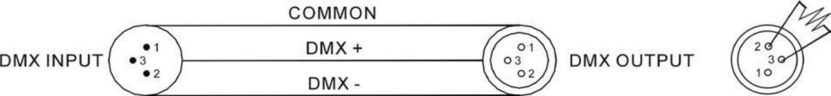
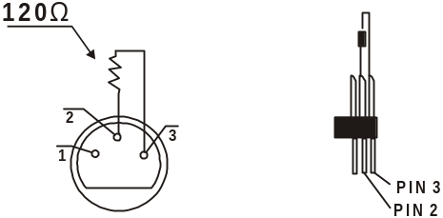
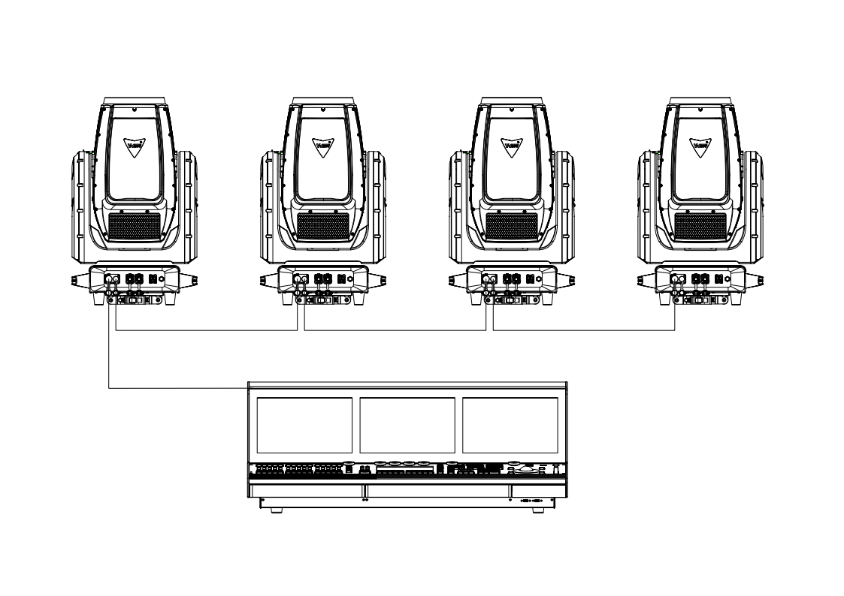

4.Address code setting
If you use a universal DMX controller to control the units, you have to set DMX address from 1 to 512 so that the units can receive DMX signal.
Press the MENU button to enter menu mode, select DMX Settings, press the ENTER button to confirm, use the UP/DOWN button to select DMX Address, press the ENTER button to confirm, the present address will blink in the display, use the UP/DOWN button to adjust the address from 001 to 512, press the ENTER button to store. Press the MENU button back to the last menu or let the unit idle 30 seconds to exit menu mode.Please refer to the following diagram to address your DMX512 channel for the first 4 units.

Channel MODE | UNIT1  ADDERSS | UNIT2  ADDERSS | UNIT3  ADDERSS | UNIT4  ADDERSS
22CH | 1.1 | 1.21 | 1.41 | 1.61
30CH | 1.1 | 1.37 | 1.73 | 1.109
31CH | 1.1 | 1.58 | 1.115 | 1.172
39CH | 1.1 | 1.67 | 1.133 | 1.199
40CH | 1.1 | 1.94 | 1.187 | 1.280

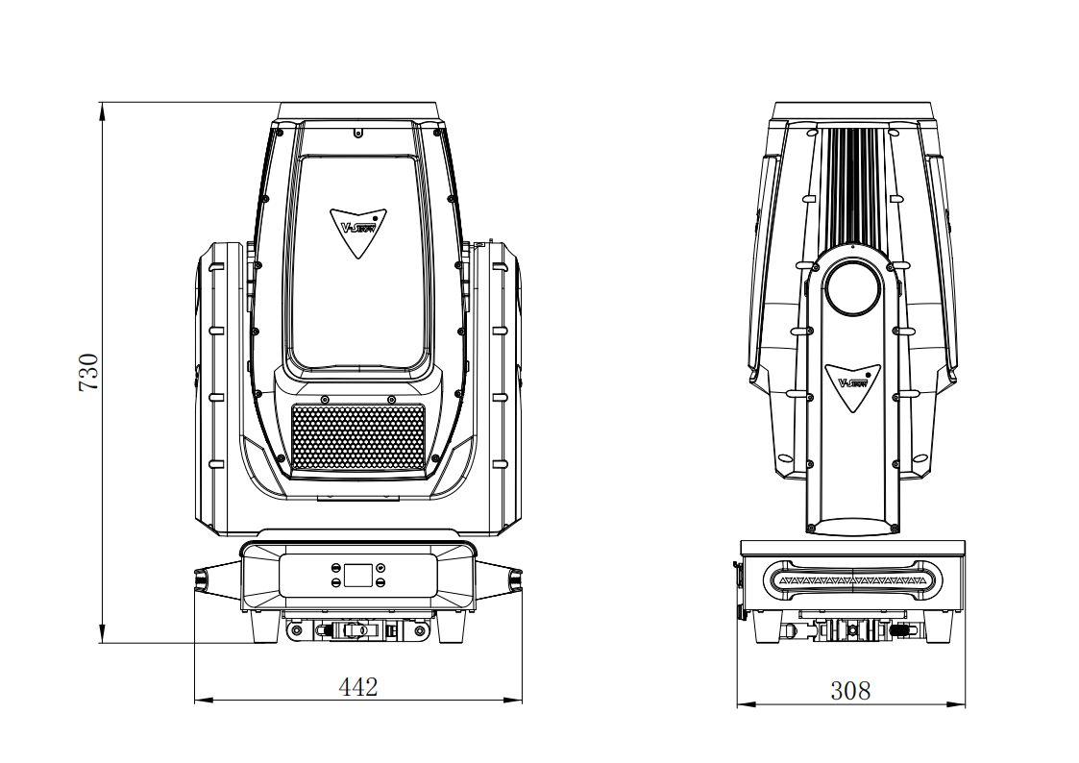
- Fixture size

6.Illuminance chart:
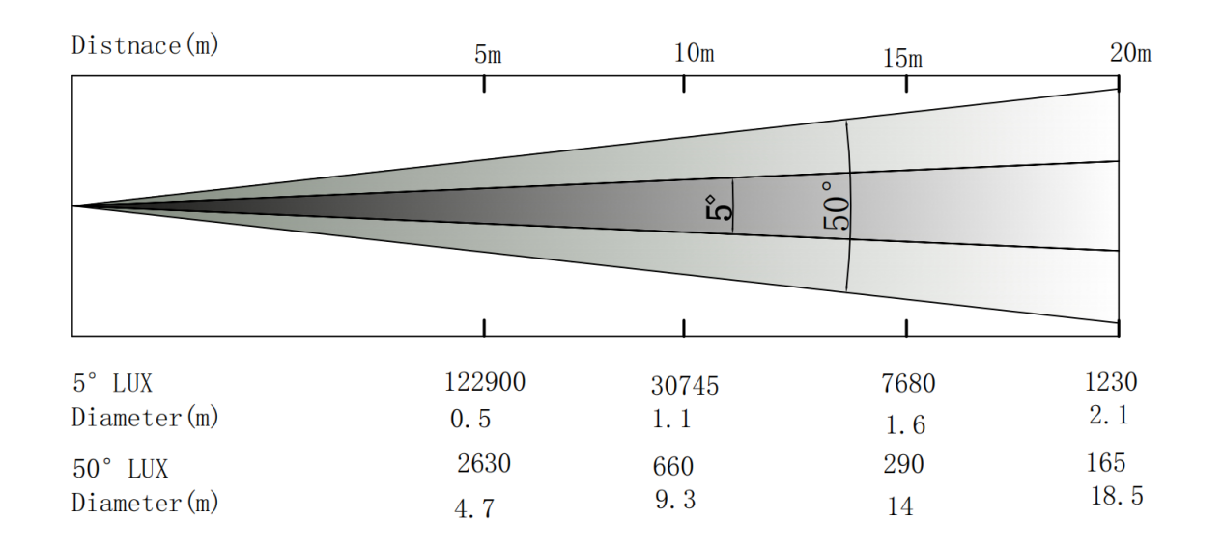


- Effect wheels
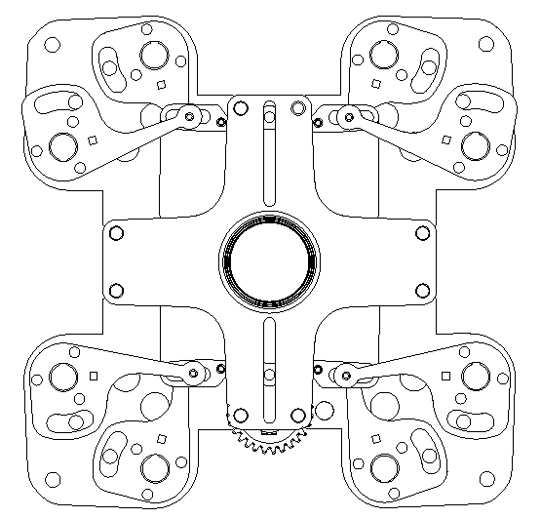


cutting disk CMY+CTO
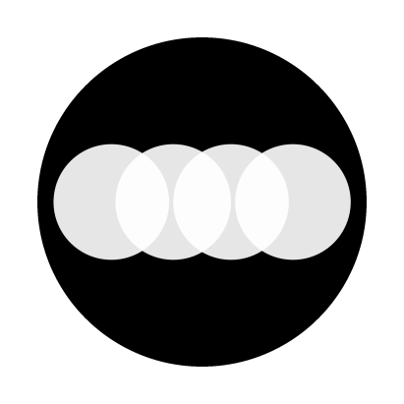

4Prism row Prism
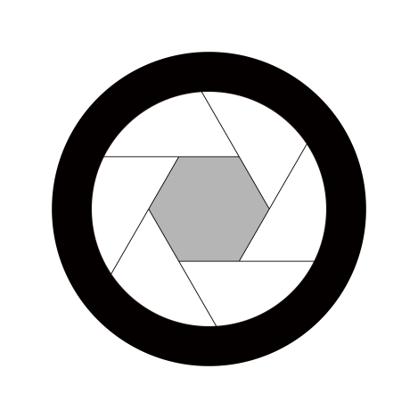
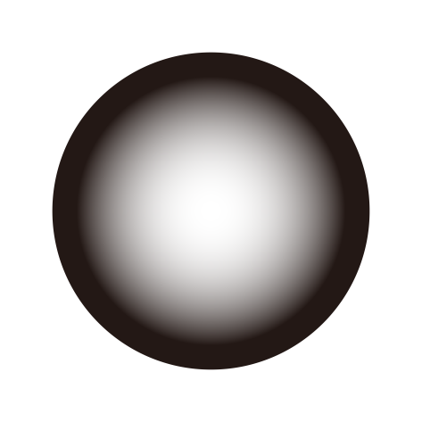

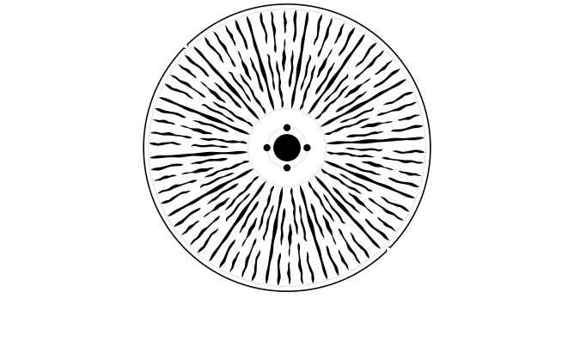
Frost Iris
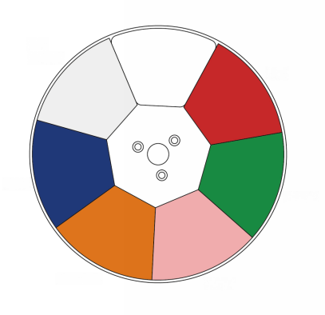

COLOR WHEEL Animation GOBO
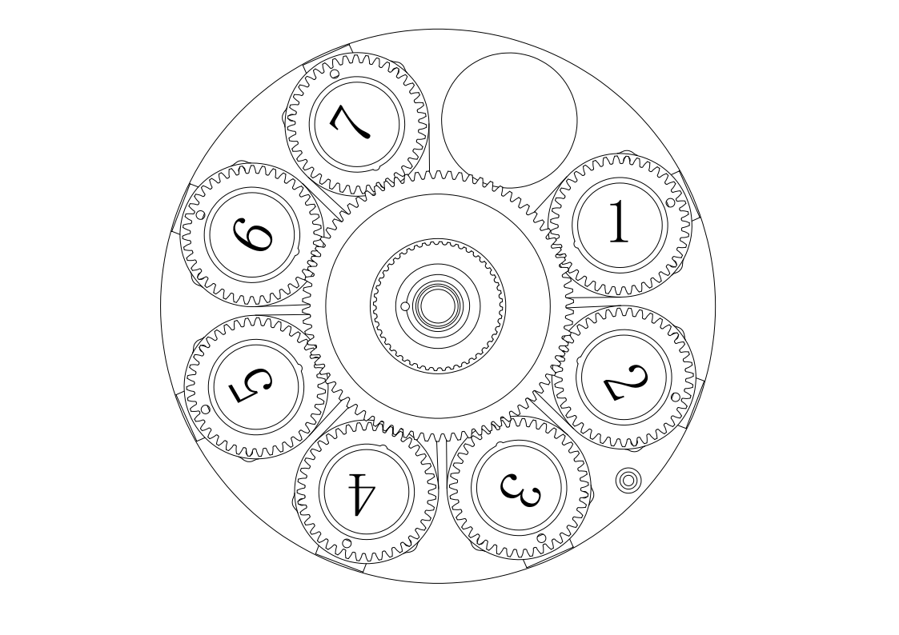

Rotation GOBO WHEEL
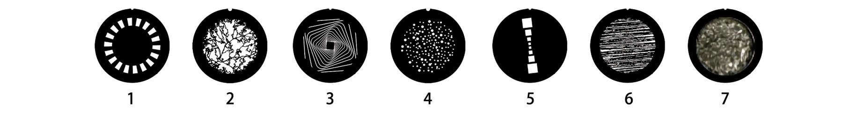
Rotation gobos

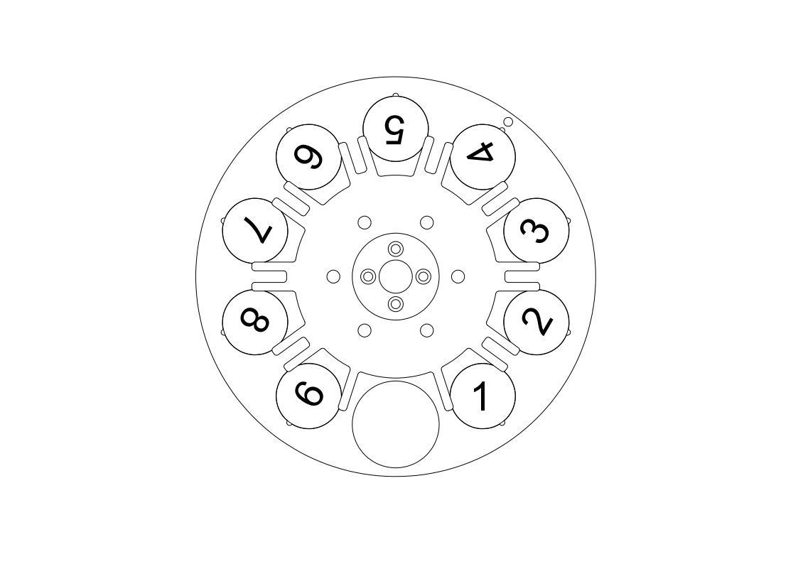

STATIC GOBO WHEEL
STATIC GOBO
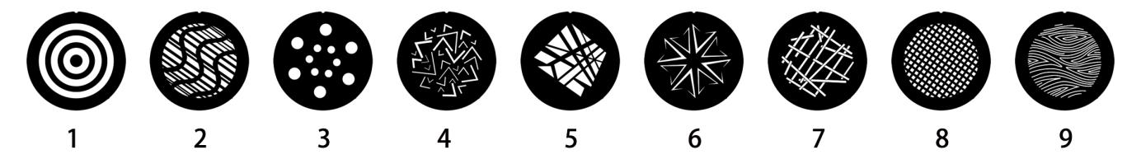

- Lamp technical parameters
Input Voltage: 100-240V, 50/60Hz
Power consumption: 1050W
Power supply: 1200W
Light source: 1000W Module LED Engine
Lifetime:≥20,000Hours
Color temperature: 7500K
Linear CTO color temperature adjustment (3000K-7000K)
Standard color rendering index Ra ≥ 70
High color rendering index Ra ≥ 90
Beam angle: 5°-50°
Linear CMY color mixing system
Color wheel: 1 color wheel, 6 fixed colors+CRI color that can be rotated in both directions
Fixed Gobo : 1 fixed gobo ,9 fixed gobo
Rotation Gobo: 1 rotating gobo , 7 Rotation Gobo, patterns can be replaced
Animation gobo, imitating water patterns and flame effects, dynamic disc rotatable
Prism:4-prism,4-sided straight mirror, both capable of bi-directional rotation
Two independent frost tablets (Mild and moderate) can be used in combination
Cutting system: 4 grating to achieve fast and smooth cutting, each grating cutting direction and Angle can be independently controlled; The entire cutting module can be rotated 120°
0-100% 16bit smooth dimming(Four dimming modes)
Adjustable refresh frequency, HD camera shooting without flicker
More strobe effects, variable speed
DMX Channel: 22/30/31/39/40CH
Operate mode: DMX512, master/slave
Electronic autofocus
Outstanding strobe effect with variable speed
Control panel: LCD touch screen
Intelligent protection of overheat temperature
X-axis rotation angle: 540°
Y-axis rotation angle: 270°
P/T: 16 bit precision scanning, no deviation
XY axis magnetic coding positioning is more accurate
Three phase motor with SY Brand
Signal socket: standard 3-pin XLR and 5-pin XLR socket or RJ45
Standard with 50MM folding fixture
Fixture size: 442x308x730mm
Protection level: IP65
Net weight: 38.KG

Feature：
fixture set light beam, spot, wash and cutting functions in one, pure color, uniform spot, color plate, glass gobo plate, CTO, CRI plate are schott materiallt, , Plug in CMY color system, Provides rich color saturation and clear seamless color transitions. LED adopts energy-saving and environment-friendly 1000W monochrome LED light engine, which can produce extremely high light output white light, color temperature of 7500K, CRIRA≥90, and zoom range 6°- 50,The cutting system consists of 4 gratings, which can be rotated ± 60°, giving designers unlimited spot creativity. Two high brightness atomizing pieces of new materials can be respectively inserted and superimposed,All day use, waterproof rating IP65

- Menu Description
Attention: screen unlock password: Up Down Up Down
First level menu | Secondary menu | Level 3 Menu | Fourth level menu
DMX set up | DMX address | 1 - 512
DMX set up | Channel mode | 39CH
DMX set up | Channel mode | 40CH
DMX set up | Channel mode | 31CH
DMX set up | Channel mode | 30CH
DMX set up | Channel mode | 22CH
DMX set up | Run mode | DMX  Auto
Personality | Pan Inverse | no
Personality | Pan Inverse | yes
Personality | Tilt Inverse | no
Personality | Tilt Inverse | yes
Personality | Tilt Feed back | off
Personality | Tilt Feed back | on
Personality | Dimming curve | Straight line
Personality | Dimming curve | Square law
Personality | Dimming curve | Inverse square law
Personality | Dimming curve | s-curve
Personality | Dimming frequency | 1200Hz
Personality | Dimming frequency | 2400Hz
Personality | Dimming frequency | 4000Hz
Personality | Dimming frequency | 6000Hz
Personality | Dimming frequency | 25000Hz
Personality | Dimming speed | fast
Personality | Dimming speed | slow
Personality | No-signal mode | keep
Personality | No-signal mode | Black field
Personality | Fan mode | Standard
Personality | Fan mode | Quiet
Personality | Fan mode | Theater
Personality | Display setting | Display Rotate | normal
Personality | Display setting | Display Rotate | Rotate 180°
Personality | Display setting | Display Intensity | 1-100
Personality | Display setting | Temperature unit | °C
Personality | Display setting | Temperature unit | °F
Personality | Display setting | Screen Lock | Off/on
Personality | Display setting | language | English
Personality | Display setting | language | Chinese
Personality | power switch | no
Personality | power switch | yes
Motor reset | Pan/Tilt | no
Motor reset | Pan/Tilt | yes
Motor reset | Effect | no
Motor reset | Effect | yes
Motor reset | ALL | no
Motor reset | ALL | yes
DMX Live | Channel list | 0 - 255
manual control | Channel list | 0 - 255
service | password | 068
Information | Power on time | xxxxxH
Information | LED hours | xxxxxH
Information | SW Version | 1U：Vxx
Information | SW Version | 2U：Vxx
Information | SW Version | 3U：Vxx
Information | SW Version | 4U：Vxx
Information | SW Version | 5U：Vxx
Information | SW Version | 6U：Vxx
Information | SW Version | 7U：Vxx
Information | RDM UID | 0xXXXX-XXXXXXXX
Information | temperature | LED | xxx
Information | Fan speed | Fan1 | xxx RPM
Information | Fan speed | Fan2 | xxx RPM
Information | Fan speed | Fan3 | xxx RPM
Information | Fan speed | Fan4 | xxx RPM

- Channel
40 Channels
CH | Function | Value | Effect
1 | Pan | 0-255 | Pan 0-540°
2 | Pan Fine | 0-255 | Pan Fine
3 | Tilt | 0-255 | Tilt 0-270°
4 | Tilt Fine | 0-255 | Tilt Fine
5 | P/T Speed | 0-255 | Fast to slow
6 | C | 0-255 | 0-100%
7 | M | 0-255 | 0-100%
8 | Y | 0-255 | 0-100%
9 | CTO | 0-255 | 0-100%
10 | Color | 0-7 | Open
10 | Color | 8-18 | color1
10 | Color | 19-29 | color2
10 | Color | 30-40 | color3
10 | Color | 41-51 | color4
10 | Color | 52-63 | color5
10 | Color | 64-67 | Open 1
10 | Color | 68-71 | Open+Color 1
10 | Color | 72-75 | Color 1
10 | Color | 76-79 | Color 1+Color 2
10 | Color | 80-83 | Color 2
10 | Color | 84-87 | Color 2+Color 3
10 | Color | 88-91 | Color 3
10 | Color | 92-95 | Color 3+Color 4
10 | Color | 96-99 | Color 4
10 | Color | 100-103 | Color 4+Color 5
10 | Color | 104-107 | Color 5
10 | Color | 108-111 | Color 5+CRI
10 | Color | 112-115 | CRI
10 | Color | 116-119 | CRI+Open
10 | Color | 120-127 | Open 2
10 | Color | 128-189 | Reverse rotation, from fast to slow
10 | Color | 190-193 | Stop
10 | Color | 194-255 | Rotate forward, going from fast to slow
11 | Rotation Gobo | 0-7 | Open
11 | Rotation Gobo | 8-15 | Gobo1
11 | Rotation Gobo | 16-23 | Gobo2
11 | Rotation Gobo | 24-31 | Gobo3
11 | Rotation Gobo | 32-39 | Gobo4
11 | Rotation Gobo | 40-47 | Gobo5
11 | Rotation Gobo | 48-55 | Gobo6
11 | Rotation Gobo | 56-63 | Gobo7
11 | Rotation Gobo | 64-72 | Gobo1shake slow to fast
11 | Rotation Gobo | 73-81 | Gobo2shake slow to fast
11 | Rotation Gobo | 82-90 | Gobo3shake slow to fast
11 | Rotation Gobo | 91-99 | Gobo4shake slow to fast
11 | Rotation Gobo | 100-108 | Gobo5shake slow to fast
11 | Rotation Gobo | 109-117 | Gobo6shake slow to fast
11 | Rotation Gobo | 118-127 | Gobo7shake slow to fast
11 | Rotation Gobo | 128-189 | Rotate forward, going from fast to slow
11 | Rotation Gobo | 190-193 | Stop
11 | Rotation Gobo | 194-255 | Reverse rotation, slow to fast
12 | Gobo Rotation | 0-127 | 0 - 360°
12 | Gobo Rotation | 128-189 | Rotate forward, going from fast to slow
12 | Gobo Rotation | 190-193 | stop
12 | Gobo Rotation | 194-255 | Reverse rotation, from fast to slow
13 | Gobo Rotation fine | 0-255 | 0-100%
14 | Fixed Gobo | 0-7 | Open
14 | Fixed Gobo | 8-13 | Gobo1
14 | Fixed Gobo | 14-19 | Gobo2
14 | Fixed Gobo | 20-25 | Gobo3
14 | Fixed Gobo | 26-31 | Gobo4
14 | Fixed Gobo | 32-37 | Gobo5
14 | Fixed Gobo | 38-43 | Gobo6
14 | Fixed Gobo | 44-49 | Gobo7
14 | Fixed Gobo | 50-55 | Gobo8
14 | Fixed Gobo | 56-63 | Gobo9
14 | Fixed Gobo | 64-70 | Gobo1shake slow to fast
14 | Fixed Gobo | 71-77 | Gobo2shake slow to fast
14 | Fixed Gobo | 78-84 | Gobo3shake slow to fast
14 | Fixed Gobo | 85-91 | Gobo4shake slow to fast
14 | Fixed Gobo | 92-98 | Gobo5shake slow to fast
14 | Fixed Gobo | 99-105 | Gobo6shake slow to fast
14 | Fixed Gobo | 106-112 | Gobo7shake slow to fast
14 | Fixed Gobo | 113-119 | Gobo8shake slow to fast
14 | Fixed Gobo | 120-127 | Gobo9shake slow to fast
14 | Fixed Gobo | 128-189 | Reverse rotation, slow to fast
14 | Fixed Gobo | 190-193 | Stop
14 | Fixed Gobo | 194-255 | Rotate forward, going from fast to slow
15 | Animation Gobo | 0-7 | Open
15 | Animation Gobo | 8-129 | Reverse rotation, slow to fast
15 | Animation Gobo | 130-133 | Stop
15 | Animation Gobo | 134-255 | Rotate forward, going from fast to slow
16 | Iris | 0-255 | 100%-0%
17 | 4 prism | 0-7 | No function
17 | 4 prism | 8-255 | Prism cut
18 | 4 Prism Rotation | 0-127 | 0 - 360°
18 | 4 Prism Rotation | 128-189 | Reverse rotation, slow to fast
18 | 4 Prism Rotation | 190-193 | Stop
18 | 4 Prism Rotation | 194-255 | Rotate forward, going from fast to slow
19 | 4 row prism | 0-7 | No function
19 | 4 row prism | 8-255 | Prism cut
20 | 4 row prism Rotation | 0-127 | 0 - 360°
20 | 4 row prism Rotation | 128-189 | Reverse rotation, slow to fast
20 | 4 row prism Rotation | 190-193 | Stop
20 | 4 row prism Rotation | 194-255 | Rotate forward, going from fast to slow
21 | CRI | 0-7 | No function
21 | CRI | 8-255 | CRI cut
22 | Frost 1 | 0-255 | 0-100%
23 | Frost 2 | 0-255 | 0-100%
24 | zoom | 0-255 | 100%-0%
25 | Zoom Fine | 0-255 | 100%-0%
26 | focus | 0-255 | 0-100%
27 | Focus Fine | 0-255 | 0-100%
28 | strobe | 0-7 | Close
28 | strobe | 8-15 | Open
28 | strobe | 16-131 | Strobe slow to fast
28 | strobe | 132-139 | Open 1
28 | strobe | 140-181 | Open quickly, close slowly,  from slow to fast
28 | strobe | 182-189 | Open 2
28 | strobe | 190-231 | Slow opening and fast closing,  from slow to fast
28 | strobe | 232-239 | Open 3
28 | strobe | 240-247 | Random strobe, from slow to fast
28 | strobe | 248-255 | Open 5
29 | dimmer | 0-255 | Dimming 0% to 100%
30 | Dimmer fine | 0-255 | Dimming fine 0% to 100%
31 | Cut rotation | 0-255 | 0-120°
32 | Cut down 1 | 0-255 | 0-100%
33 | Cut down 2 | 0-255 | 0-100%
34 | Cut on1 | 0-255 | 0-100%
35 | Cut on 2 | 0-255 | 0-100%
36 | Cut left1 | 0-255 | 0-100%
37 | Cut left2 | 0-255 | 0-100%
38 | Cut right1 | 0-255 | 0-100%
39 | Cut right2 | 0-255 | 0-100%
40 | Function settings | 0-29 | No function
40 | Function settings | 30-39 | Dimming curve: square law
40 | Function settings | 40-49 | Dimming curve: inverse square law
40 | Function settings | 50-59 | Dimming curve: Linear dimmer
40 | Function settings | 60-69 | Dimming curve: S- curve
40 | Function settings | 70-79 | Fan mode: Auto
40 | Function settings | 80-89 | Fan mode: Low speed
40 | Function settings | 90-99 | Fan mode: High speed
40 | Function settings | 100-119 | No function
40 | Function settings | 120-129 | 1200Hz
40 | Function settings | 130-139 | 2400Hz
40 | Function settings | 140-149 | 4000Hz
40 | Function settings | 150-159 | 6000Hz
40 | Function settings | 160-169 | 25000Hz
40 | Function settings | 170-179 | No function
40 | Function settings | 180-189 | Dimming speed: fast
40 | Function settings | 190-199 | Dimming speed: Slow
40 | Function settings | 200-209 | Reset all motors
40 | Function settings | 210-219 | Head motor reset
40 | Function settings | 220-229 | P/T motor reset
40 | Function settings | 230-255 | No function
39Channels
CH | Function | Value | Effect
1 | Pan | 0-255 | Pan 0-540°
2 | Pan Fine | 0-255 | Pan Fine
3 | Tilt | 0-255 | Tilt 0-270°
4 | Tilt Fine | 0-255 | Tilt Fine
5 | P/T Speed | 0-255 | Fast to slow
6 | C | 0-255 | 0-100%
7 | M | 0-255 | 0-100%
8 | Y | 0-255 | 0-100%
9 | CTO | 0-255 | 0-100%
10 | Color | 0-7 | Open
10 | Color | 8-18 | color1
10 | Color | 19-29 | color2
10 | Color | 30-40 | color3
10 | Color | 41-51 | color4
10 | Color | 52-63 | color5
10 | Color | 64-67 | Open 1
10 | Color | 68-71 | Open+Color 1
10 | Color | 72-75 | Color 1
10 | Color | 76-79 | Color 1+Color 2
10 | Color | 80-83 | Color 2
10 | Color | 84-87 | Color 2+Color 3
10 | Color | 88-91 | Color 3
10 | Color | 92-95 | Color 3+Color 4
10 | Color | 96-99 | Color 4
10 | Color | 100-103 | Color 4+Color 5
10 | Color | 104-107 | Color 5
10 | Color | 108-111 | Color 5+CRI
10 | Color | 112-115 | CRI
10 | Color | 116-119 | CRI+Open
10 | Color | 120-127 | Open 2
10 | Color | 128-189 | Reverse rotation, from fast to slow
10 | Color | 190-193 | Stop
10 | Color | 194-255 | Rotate forward, going from fast to slow
11 | Rotation Gobo | 0-7 | Open
11 | Rotation Gobo | 8-15 | Gobo1
11 | Rotation Gobo | 16-23 | Gobo2
11 | Rotation Gobo | 24-31 | Gobo3
11 | Rotation Gobo | 32-39 | Gobo4
11 | Rotation Gobo | 40-47 | Gobo5
11 | Rotation Gobo | 48-55 | Gobo6
11 | Rotation Gobo | 56-63 | Gobo7
11 | Rotation Gobo | 64-72 | Gobo1shake slow to fast
11 | Rotation Gobo | 73-81 | Gobo2shake slow to fast
11 | Rotation Gobo | 82-90 | Gobo3shake slow to fast
11 | Rotation Gobo | 91-99 | Gobo4shake slow to fast
11 | Rotation Gobo | 100-108 | Gobo5shake slow to fast
11 | Rotation Gobo | 109-117 | Gobo6shake slow to fast
11 | Rotation Gobo | 118-127 | Gobo7shake slow to fast
11 | Rotation Gobo | 128-189 | Rotate forward, going from fast to slow
11 | Rotation Gobo | 190-193 | Stop
11 | Rotation Gobo | 194-255 | Reverse rotation, slow to fast
12 | Gobo Rotation | 0-127 | 0 - 360°
12 | Gobo Rotation | 128-189 | Rotate forward, going from fast to slow
12 | Gobo Rotation | 190-193 | stop
12 | Gobo Rotation | 194-255 | Reverse rotation, from fast to slow
13 | Fixed Gobo | 0-7 | Open
13 | Fixed Gobo | 8-13 | Gobo1
13 | Fixed Gobo | 14-19 | Gobo2
13 | Fixed Gobo | 20-25 | Gobo3
13 | Fixed Gobo | 26-31 | Gobo4
13 | Fixed Gobo | 32-37 | Gobo5
13 | Fixed Gobo | 38-43 | Gobo6
13 | Fixed Gobo | 44-49 | Gobo7
13 | Fixed Gobo | 50-55 | Gobo8
13 | Fixed Gobo | 56-63 | Gobo9
13 | Fixed Gobo | 64-70 | Gobo1shake slow to fast
13 | Fixed Gobo | 71-77 | Gobo2shake slow to fast
13 | Fixed Gobo | 78-84 | Gobo3shake slow to fast
13 | Fixed Gobo | 85-91 | Gobo4shake slow to fast
13 | Fixed Gobo | 92-98 | Gobo5shake slow to fast
13 | Fixed Gobo | 99-105 | Gobo6shake slow to fast
13 | Fixed Gobo | 106-112 | Gobo7shake slow to fast
13 | Fixed Gobo | 113-119 | Gobo8shake slow to fast
13 | Fixed Gobo | 120-127 | Gobo9shake slow to fast
13 | Fixed Gobo | 128-189 | Reverse rotation, slow to fast
13 | Fixed Gobo | 190-193 | Stop
13 | Fixed Gobo | 194-255 | Rotate forward, going from fast to slow
14 | Animation Gobo | 0-7 | Open
14 | Animation Gobo | 8-129 | Reverse rotation, slow to fast
14 | Animation Gobo | 130-133 | Stop
14 | Animation Gobo | 134-255 | Rotate forward, going from fast to slow
15 | Iris | 0-255 | 100%-0%
16 | 4 prism | 0-7 | No function
16 | 4 prism | 8-255 | Prism cut
17 | 4 Prism Rotation | 0-127 | 0 - 360°
17 | 4 Prism Rotation | 128-189 | Reverse rotation, slow to fast
17 | 4 Prism Rotation | 190-193 | Stop
17 | 4 Prism Rotation | 194-255 | Rotate forward, going from fast to slow
18 | 4 row prism | 0-7 | No function
18 | 4 row prism | 8-255 | Prism cut
19 | 4 row prism Rotation | 0-127 | 0 - 360°
19 | 4 row prism Rotation | 128-189 | Reverse rotation, slow to fast
19 | 4 row prism Rotation | 190-193 | Stop
19 | 4 row prism Rotation | 194-255 | Rotate forward, going from fast to slow
20 | CRI | 0-7 | No function
20 | CRI | 8-255 | CRI cut
21 | Frost 1 | 0-255 | 0-100%
22 | Frost 2 | 0-255 | 0-100%
23 | zoom | 0-255 | 100%-0%
24 | Zoom Fine | 0-255 | 100%-0%
25 | focus | 0-255 | 0-100%
26 | Focus Fine | 0-255 | 0-100%
27 | strobe | 0-7 | Close
27 | strobe | 8-15 | Open
27 | strobe | 16-131 | Strobe slow to fast
27 | strobe | 132-139 | Open 1
27 | strobe | 140-181 | Open quickly, close slowly,  from slow to fast
27 | strobe | 182-189 | Open 2
27 | strobe | 190-231 | Slow opening and fast closing,  from slow to fast
27 | strobe | 232-239 | Open 3
27 | strobe | 240-247 | Random strobe, from slow to fast
27 | strobe | 248-255 | Open 5
28 | dimmer | 0-255 | Dimming 0% to 100%
29 | Dimmer fine | 0-255 | Dimming fine 0% to 100%
30 | Cut rotation | 0-255 | 0-120°
31 | Cut down 1 | 0-255 | 0-100%
32 | Cut down 2 | 0-255 | 0-100%
33 | Cut on1 | 0-255 | 0-100%
34 | Cut on 2 | 0-255 | 0-100%
35 | Cut left1 | 0-255 | 0-100%
36 | Cut left2 | 0-255 | 0-100%
37 | Cut right1 | 0-255 | 0-100%
38 | Cut right2 | 0-255 | 0-100%
39 | Function settings | 0-29 | No function
39 | Function settings | 30-39 | Dimming curve: square law
39 | Function settings | 40-49 | Dimming curve: inverse square law
39 | Function settings | 50-59 | Dimming curve: Linear dimmer
39 | Function settings | 60-69 | Dimming curve: S- curve
39 | Function settings | 70-79 | Fan mode: Auto
39 | Function settings | 80-89 | Fan mode: Low speed
39 | Function settings | 90-99 | Fan mode: High speed
39 | Function settings | 100-119 | No function
39 | Function settings | 120-129 | 1200Hz
39 | Function settings | 130-139 | 2400Hz
39 | Function settings | 140-149 | 4000Hz
39 | Function settings | 150-159 | 6000Hz
39 | Function settings | 160-169 | 25000Hz
39 | Function settings | 170-179 | No function
39 | Function settings | 180-189 | Dimming speed: fast
39 | Function settings | 190-199 | Dimming speed: Slow
39 | Function settings | 200-209 | Reset all motors
39 | Function settings | 210-219 | Head motor reset
39 | Function settings | 220-229 | P/T motor reset
39 | Function settings | 230-255 | No function
31 Channels
CH | Function | Value | Effect
1 | Pan | 0-255 | Pan 0-540°
2 | Pan Fine | 0-255 | Pan Fine
3 | Tilt | 0-255 | Tilt 0-270°
4 | Tilt Fine | 0-255 | Tilt Fine
5 | P/T Speed | 0-255 | Fast to slow
6 | C | 0-255 | 0-100%
7 | M | 0-255 | 0-100%
8 | Y | 0-255 | 0-100%
9 | CTO | 0-255 | 0-100%
10 | Color | 0-7 | Open
10 | Color | 8-18 | color1
10 | Color | 19-29 | color2
10 | Color | 30-40 | color3
10 | Color | 41-51 | color4
10 | Color | 52-63 | color5
10 | Color | 64-67 | Open 1
10 | Color | 68-71 | Open+Color 1
10 | Color | 72-75 | Color 1
10 | Color | 76-79 | Color 1+Color 2
10 | Color | 80-83 | Color 2
10 | Color | 84-87 | Color 2+Color 3
10 | Color | 88-91 | Color 3
10 | Color | 92-95 | Color 3+Color 4
10 | Color | 96-99 | Color 4
10 | Color | 100-103 | Color 4+Color 5
10 | Color | 104-107 | Color 5
10 | Color | 108-111 | Color 5+CRI
10 | Color | 112-115 | CRI
10 | Color | 116-119 | CRI+Open
10 | Color | 120-127 | Open 2
10 | Color | 128-189 | Reverse rotation, from fast to slow
10 | Color | 190-193 | Stop
10 | Color | 194-255 | Rotate forward, going from fast to slow
11 | Iris | 0-255 | 100%-0%
12 | CRI | 0-7 | No function
12 | CRI | 8-255 | CRI cut
13 | Frost 1 | 0-255 | 0-100%
14 | Frost 2 | 0-255 | 0-100%
15 | zoom | 0-255 | 100%-0%
16 | Zoom Fine | 0-255 | 100%-0%
17 | focus | 0-255 | 0-100%
18 | Focus Fine | 0-255 | 0-100%
19 | strobe | 0-7 | Close
19 | strobe | 8-15 | Open
19 | strobe | 16-131 | Strobe slow to fast
19 | strobe | 132-139 | Open 1
19 | strobe | 140-181 | Open quickly, close slowly,  from slow to fast
19 | strobe | 182-189 | Open 2
19 | strobe | 190-231 | Slow opening and fast closing,  from slow to fast
19 | strobe | 232-239 | Open 3
19 | strobe | 240-247 | Random strobe, from slow to fast
19 | strobe | 248-255 | Open 5
20 | dimmer | 0-255 | Dimming 0% to 100%
21 | Dimmer fine | 0-255 | Dimming fine 0% to 100%
22 | Cut rotation | 0-255 | 0-120°
23 | Cut down 1 | 0-255 | 0-100%
24 | Cut down 2 | 0-255 | 0-100%
25 | Cut on1 | 0-255 | 0-100%
26 | Cut on 2 | 0-255 | 0-100%
27 | Cut left1 | 0-255 | 0-100%
28 | Cut left2 | 0-255 | 0-100%
29 | Cut right1 | 0-255 | 0-100%
30 | Cut right2 | 0-255 | 0-100%
31 | Function settings | 0-29 | No function
31 | Function settings | 30-39 | Dimming curve: square law
31 | Function settings | 40-49 | Dimming curve: inverse square law
31 | Function settings | 50-59 | Dimming curve: Linear dimmer
31 | Function settings | 60-69 | Dimming curve: S- curve
31 | Function settings | 70-79 | Fan mode: Auto
31 | Function settings | 80-89 | Fan mode: Low speed
31 | Function settings | 90-99 | Fan mode: High speed
31 | Function settings | 100-119 | No function
31 | Function settings | 120-129 | 1200Hz
31 | Function settings | 130-139 | 2400Hz
31 | Function settings | 140-149 | 4000Hz
31 | Function settings | 150-159 | 6000Hz
31 | Function settings | 160-169 | 25000Hz
31 | Function settings | 170-179 | No function
31 | Function settings | 180-189 | Dimming speed: fast
31 | Function settings | 190-199 | Dimming speed: Slow
31 | Function settings | 200-209 | Reset all motors
31 | Function settings | 210-219 | Head motor reset
31 | Function settings | 220-229 | P/T motor reset
31 | Function settings | 230-255 | No function

30Channels
CH | Function | Value | Effect
1 | Pan | 0-255 | Pan 0-540°
2 | Pan Fine | 0-255 | Pan Fine
3 | Tilt | 0-255 | Tilt 0-270°
4 | Tilt Fine | 0-255 | Tilt Fine
5 | P/T Speed | 0-255 | Fast to slow
6 | C | 0-255 | 0-100%
7 | M | 0-255 | 0-100%
8 | Y | 0-255 | 0-100%
9 | CTO | 0-255 | 0-100%
10 | Color | 0-7 | Open
10 | Color | 8-18 | color1
10 | Color | 19-29 | color2
10 | Color | 30-40 | color3
10 | Color | 41-51 | color4
10 | Color | 52-63 | color5
10 | Color | 64-67 | Open 1
10 | Color | 68-71 | Open+Color 1
10 | Color | 72-75 | Color 1
10 | Color | 76-79 | Color 1+Color 2
10 | Color | 80-83 | Color 2
10 | Color | 84-87 | Color 2+Color 3
10 | Color | 88-91 | Color 3
10 | Color | 92-95 | Color 3+Color 4
10 | Color | 96-99 | Color 4
10 | Color | 100-103 | Color 4+Color 5
10 | Color | 104-107 | Color 5
10 | Color | 108-111 | Color 5+CRI
10 | Color | 112-115 | CRI
10 | Color | 116-119 | CRI+Open
10 | Color | 120-127 | Open 2
10 | Color | 128-189 | Reverse rotation, speed from fast to slow
10 | Color | 190-193 | Stop
10 | Color | 194-255 | Rotate forward, going from fast to slow
11 | Rotation Gobo | 0-7 | Open
11 | Rotation Gobo | 8-15 | Gobo1
11 | Rotation Gobo | 16-23 | Gobo2
11 | Rotation Gobo | 24-31 | Gobo3
11 | Rotation Gobo | 32-39 | Gobo4
11 | Rotation Gobo | 40-47 | Gobo5
11 | Rotation Gobo | 48-55 | Gobo6
11 | Rotation Gobo | 56-63 | Gobo7
11 | Rotation Gobo | 64-72 | Gobo1shake slow to fast
11 | Rotation Gobo | 73-81 | Gobo2shake slow to fast
11 | Rotation Gobo | 82-90 | Gobo3shake slow to fast
11 | Rotation Gobo | 91-99 | Gobo4shake slow to fast
11 | Rotation Gobo | 100-108 | Gobo5shake slow to fast
11 | Rotation Gobo | 109-117 | Gobo6shake slow to fast
11 | Rotation Gobo | 118-127 | Gobo7shake slow to fast
11 | Rotation Gobo | 128-189 | Rotate forward, going from fast to slow
11 | Rotation Gobo | 190-193 | Stop
11 | Rotation Gobo | 194-255 | Reverse rotation, slow to fast
12 | Gobo Rotation | 0-127 | 0 - 360°
12 | Gobo Rotation | 128-189 | Rotate forward, going from fast to slow
12 | Gobo Rotation | 190-193 | stop
12 | Gobo Rotation | 194-255 | Reverse rotation, from fast to slow
13 | Fixed Gobo | 0-7 | Open
13 | Fixed Gobo | 8-13 | Gobo1
13 | Fixed Gobo | 14-19 | Gobo2
13 | Fixed Gobo | 20-25 | Gobo3
13 | Fixed Gobo | 26-31 | Gobo4
13 | Fixed Gobo | 32-37 | Gobo5
13 | Fixed Gobo | 38-43 | Gobo6
13 | Fixed Gobo | 44-49 | Gobo7
13 | Fixed Gobo | 50-55 | Gobo8
13 | Fixed Gobo | 56-63 | Gobo9
13 | Fixed Gobo | 64-70 | Gobo1shake slow to fast
13 | Fixed Gobo | 71-77 | Gobo2shake slow to fast
13 | Fixed Gobo | 78-84 | Gobo3shake slow to fast
13 | Fixed Gobo | 85-91 | Gobo4shake slow to fast
13 | Fixed Gobo | 92-98 | Gobo5shake slow to fast
13 | Fixed Gobo | 99-105 | Gobo6shake slow to fast
13 | Fixed Gobo | 106-112 | Gobo7shake slow to fast
13 | Fixed Gobo | 113-119 | Gobo8shake slow to fast
13 | Fixed Gobo | 120-127 | Gobo9shake slow to fast
13 | Fixed Gobo | 128-189 | Reverse rotation, slow to fast
13 | Fixed Gobo | 190-193 | Stop
13 | Fixed Gobo | 194-255 | Rotate forward, going from fast to slow
14 | Animation Gobo | 0-7 | Open
14 | Animation Gobo | 8-129 | Reverse rotation, slow to fast
14 | Animation Gobo | 130-133 | Stop
14 | Animation Gobo | 134-255 | Rotate forward, going from fast to slow
15 | Iris | 0-255 | 100%-0%
16 | 4 prism | 0-7 | No function
16 | 4 prism | 8-255 | Prism cut
17 | 4 Prism Rotation | 0-127 | 0 - 360°
17 | 4 Prism Rotation | 128-189 | Reverse rotation, slow to fast
17 | 4 Prism Rotation | 190-193 | Stop
17 | 4 Prism Rotation | 194-255 | Rotate forward, going from fast to slow
18 | 4 row prism | 0-7 | No function
18 | 4 row prism | 8-255 | Prism cut
19 | 4 row prism Rotation | 0-127 | 0 - 360°
19 | 4 row prism Rotation | 128-189 | Reverse rotation, slow to fast
19 | 4 row prism Rotation | 190-193 | Stop
19 | 4 row prism Rotation | 194-255 | Rotate forward, going from fast to slow
20 | CRI | 0-7 | No function
20 | CRI | 8-255 | CRI cut
21 | Frost 1 | 0-255 | 0-100%
22 | Frost 2 | 0-255 | 0-100%
23 | zoom | 0-255 | 100%-0%
24 | Zoom Fine | 0-255 | 100%-0%
25 | focus | 0-255 | 0-100%
26 | Focus Fine | 0-255 | 0-100%
27 | strobe | 0-7 | Close
27 | strobe | 8-15 | Open
27 | strobe | 16-131 | Strobe slow to fast
27 | strobe | 132-139 | Open 1
27 | strobe | 140-181 | Open quickly, close slowly,  from slow to fast
27 | strobe | 182-189 | Open 2
27 | strobe | 190-231 | Slow opening and fast closing,  from slow to fast
27 | strobe | 232-239 | Open 3
27 | strobe | 240-247 | Random strobe, from slow to fast
27 | strobe | 248-255 | Open 5
28 | dimmer | 0-255 | Dimming 0% to 100%
29 | Dimmer fine | 0-255 | Dimming fine 0% to 100%
30 | Function settings | 0-29 | No function
30 | Function settings | 30-39 | Dimming curve: square law
30 | Function settings | 40-49 | Dimming curve: inverse square law
30 | Function settings | 50-59 | Dimming curve: Linear dimmer
30 | Function settings | 60-69 | Dimming curve: S- curve
30 | Function settings | 70-79 | Fan mode: Auto
30 | Function settings | 80-89 | Fan mode: Low speed
30 | Function settings | 90-99 | Fan mode: High speed
30 | Function settings | 100-119 | No function
30 | Function settings | 120-129 | 1200Hz
30 | Function settings | 130-139 | 2400Hz
30 | Function settings | 140-149 | 4000Hz
30 | Function settings | 150-159 | 6000Hz
30 | Function settings | 160-169 | 25000Hz
30 | Function settings | 170-179 | No function
30 | Function settings | 180-189 | Dimming speed: fast
30 | Function settings | 190-199 | Dimming speed: Slow
30 | Function settings | 200-209 | Reset all motors
30 | Function settings | 210-219 | Head motor reset
30 | Function settings | 220-229 | P/T motor reset
30 | Function settings | 230-255 | No function
22Channels
CH | Function | Value | Effect
1 | Pan | 0-255 | Pan 0-540°
2 | Pan Fine | 0-255 | Pan Fine
3 | Tilt | 0-255 | Tilt 0-270°
4 | Tilt Fine | 0-255 | Tilt Fine
5 | P/T Speed | 0-255 | Fast to slow
6 | C | 0-255 | 0-100%
7 | M | 0-255 | 0-100%
8 | Y | 0-255 | 0-100%
9 | CTO | 0-255 | 0-100%
10 | Color | 0-7 | Open
10 | Color | 8-18 | color1
10 | Color | 19-29 | color2
10 | Color | 30-40 | color3
10 | Color | 41-51 | color4
10 | Color | 52-63 | color5
10 | Color | 64-67 | Open 1
10 | Color | 68-71 | Open+Color 1
10 | Color | 72-75 | Color 1
10 | Color | 76-79 | Color 1+Color 2
10 | Color | 80-83 | Color 2
10 | Color | 84-87 | Color 2+Color 3
10 | Color | 88-91 | Color 3
10 | Color | 92-95 | Color 3+Color 4
10 | Color | 96-99 | Color 4
10 | Color | 100-103 | Color 4+Color 5
10 | Color | 104-107 | Color 5
10 | Color | 108-111 | Color 5+CRI
10 | Color | 112-115 | CRI
10 | Color | 116-119 | CRI+Open
10 | Color | 120-127 | Open 2
10 | Color | 128-189 | Reverse rotation,from fast to slow
10 | Color | 190-193 | Stop
10 | Color | 194-255 | Rotate forward, going from fast to slow
11 | Iris | 0-255 | 100%-0%
12 | CRI | 0-7 | No function
12 | CRI | 8-255 | CRI cut
13 | Frost 1 | 0-255 | 0-100%
14 | Frost 2 | 0-255 | 0-100%
15 | zoom | 0-255 | 100%-0%
16 | Zoom Fine | 0-255 | 100%-0%
17 | focus | 0-255 | 0-100%
18 | Focus Fine | 0-255 | 0-100%
19 | strobe | 0-7 | Close
19 | strobe | 8-15 | Open
19 | strobe | 16-131 | Strobe slow to fast
19 | strobe | 132-139 | Open 1
19 | strobe | 140-181 | Open quickly, close slowly,  from slow to fast
19 | strobe | 182-189 | Open 2
19 | strobe | 190-231 | Slow opening and fast closing,  from slow to fast
19 | strobe | 232-239 | Open 3
19 | strobe | 240-247 | Random strobe, from slow to fast
19 | strobe | 248-255 | Open 5
20 | dimmer | 0-255 | Dimming 0% to 100%
21 | Dimmer fine | 0-255 | Dimming fine 0% to 100%
22 | Function settings | 0-29 | No function
22 | Function settings | 30-39 | Dimming curve: square law
22 | Function settings | 40-49 | Dimming curve: inverse square law
22 | Function settings | 50-59 | Dimming curve: Linear dimmer
22 | Function settings | 60-69 | Dimming curve: S- curve
22 | Function settings | 70-79 | Fan mode: Auto
22 | Function settings | 80-89 | Fan mode: Low speed
22 | Function settings | 90-99 | Fan mode: High speed
22 | Function settings | 100-119 | No function
22 | Function settings | 120-129 | 1200Hz
22 | Function settings | 130-139 | 2400Hz
22 | Function settings | 140-149 | 4000Hz
22 | Function settings | 150-159 | 6000Hz
22 | Function settings | 160-169 | 25000Hz
22 | Function settings | 170-179 | No function
22 | Function settings | 180-189 | Dimming speed: fast
22 | Function settings | 190-199 | Dimming speed: Slow
22 | Function settings | 200-209 | Reset all motors
22 | Function settings | 210-219 | Head motor reset
22 | Function settings | 220-229 | P/T motor reset
22 | Function settings | 230-255 | No function

11.Troubleshooting
Following are a few common problems that may occur during operation. Here are some
suggestions for troubleshooting:
A. The unit does not work, no light and the fan does not work
1. Check the connected power and main fuse.
2. Measure the voltage.
3. Check the power indicator to see whether it can be lit up or not.
B. Not responding to the DMX controller
1. Check whether the DMX connectors and the DMX cables are connected correctly.
2. Check whether the DMX address is correctly set.
3. If the intermittent DMX signal problem occurs, check whether the XLR socket and the signal
cable are well connected.
4. Try it with another DMX controller.
5. Check whether the DMX cables run near or alongside to the high-voltage cables, which may
damage or interfere with the signal circuit.
C. One of the channels is not working well
1. The stepper motor might be damaged or the cable connected to the PCB might be broken.
2. The motor’s drive IC on the PCB might be out of condition.
12.Fixture cleaning
It is absolutely essential that the fixture is kept clean to ensure the maximum light-output and allow
the fixture to function reliably throughout its life. The fixture must be cleaned regularly to avoid dust,
dirt and smoke-fluid residues building up on or within the fixture. The cleaning frequency depends on
the application environment. Clean the fixture immediately if the dust enters it to avoid damage to
the optical lens due to excessive dust.
• A soft lint-free cloth moistened with any good glass cleaning fluid is recommended, under no
circumstances should solvents be used.
• Always dry the parts carefully.
• Clean the external optical lens at least every 20 days and the internal optical lens every 30 days.

